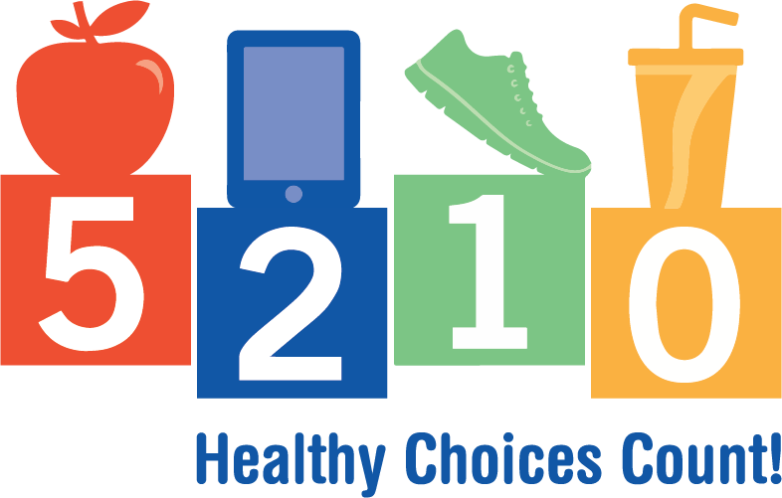

Date:

Dear Families:

We are pleased to announce that we have teamed up with 5-2-1-0 Healthy Choices Count! This initiative is helping create healthier environments in schools, child care and out-of-school programs, health care practices, workplaces, and communities — the places where children and their families live, learn, work, and play. It is centered around the common message of 5-2-1-0:

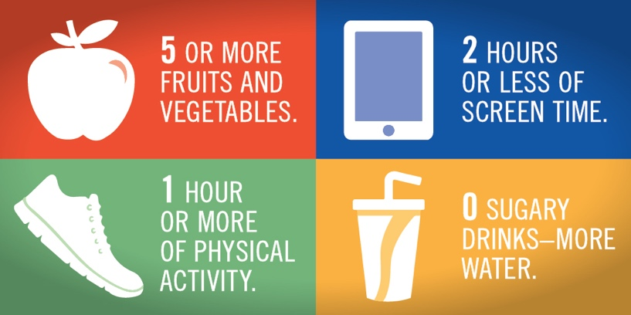

As a part of 5-2-1-0 Healthy Choices Count!, we will be working hard to improve our nutrition and physical activity environment and adding the 5-2-1-0 behaviors into our daily activities. As part of our work, you may hear your child talking about 5-2-1-0. Don’t hesitate to get involved or ask what we are working on.

For more information about 5-2-1-0 Healthy Choices Count!, visit www.healthieststateiowa.com/5210, or contact name at xxx-xxx-xxxx or name@email.com

Sincerely,

NAME

TITLE

