NOTE: Please feel free to edit this document as appropriate to best distribute via your employee communication channels. Examples of ways to share this message include staff email, wellness newsletter, employee intranet, bulletin board, etc.

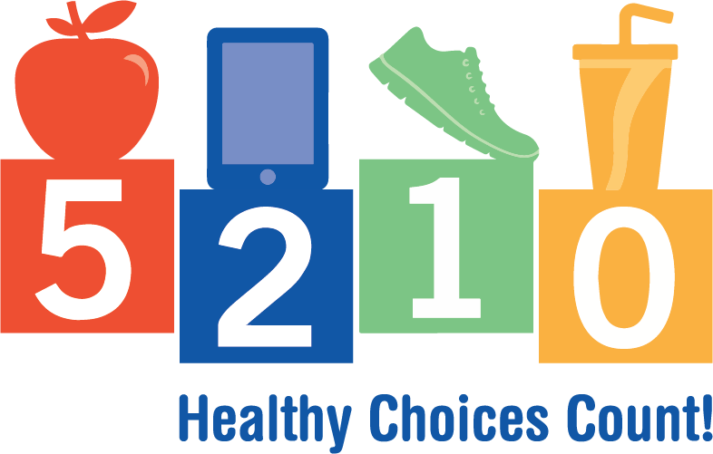
Date:

Dear Employees:

We are pleased to announce that we have signed up as a 5-2-1-0 Healthy Choices Count! Registered Workplace.
This initiative, led by the Healthiest State Initiative and the Iowa Department of Public Health, is helping create healthier environments in educational settings, health care practices, workplaces, and communities — the places where Iowa families live, learn, work, and play.

As a 5-2-1-0 Healthy Choices Count! Registered Workplace, we have committed to help our workforce Eat Well, Move More and Feel Better. Over the coming weeks and months, you may notice the wellness committee making efforts to improve our nutrition, physical activity and wellness environment. We want to make the healthy choice the easy choice at our workplace.

For more information about 5-2-1-0 Healthy Choices Count!, visit IowaHealthiestState.com/5210. For more information on how our workplace will be implementing this initiative, contact name at xxx-xxx-xxxx or name@email.com.

Sincerely,

NAME

TITLE

